# **Exercise 1 - Retrieving System Information.**

The administrator will benefit greatly from having a complete profile of the hardware and software components in order to successfully maintain the computer. System Information is a Windows program that gives you diagnostic and troubleshooting information about your computer resources on the computer

Furthermore, the administrator can view information about other computers on the network while signed into one computer.

In this exercise,

1. Let’s collect system information on a Windows 11 - for both the logged-in computer and other computers on the network.

## **Topology**

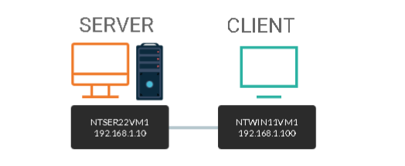

DOMAIN = networktute.com

NTSER22VM1 = Windows Server 2022 – Domain Controller

NTWIN11VM1 = Windows 11 – Domain Member

## **Prerequisite**

* *VMware Workstation 16 Pro*
  + When making this tutorial, we used the “Windows Server 2019” VM Template and “Windows 10 & later” VM Template. Since VMware didn’t have the updated templates.
* *Microsoft Windows Server 2022*
* *Microsoft Windows 11*

## **Task 1: Use System Information Tool to Collect Local Information**

Only when the System Information utility is run with administrative privileges does it present accurate data. Otherwise, it may incorrectly show some drivers as not operating or stopped. To launch the utility with elevated permissions, do the following:

* Login as the administrator on the computer

You can save the presented information as a file, print it, or even export it using the System Information tool.

In this task, we will use the System Information tool to collect local system information on the NTWIN11VM1 computer.

**Step 1:**

Make sure you are connected to **NTWIN11VM1**.

Click in the Type here to search textbox and type: ***system information***

Press **Enter.**

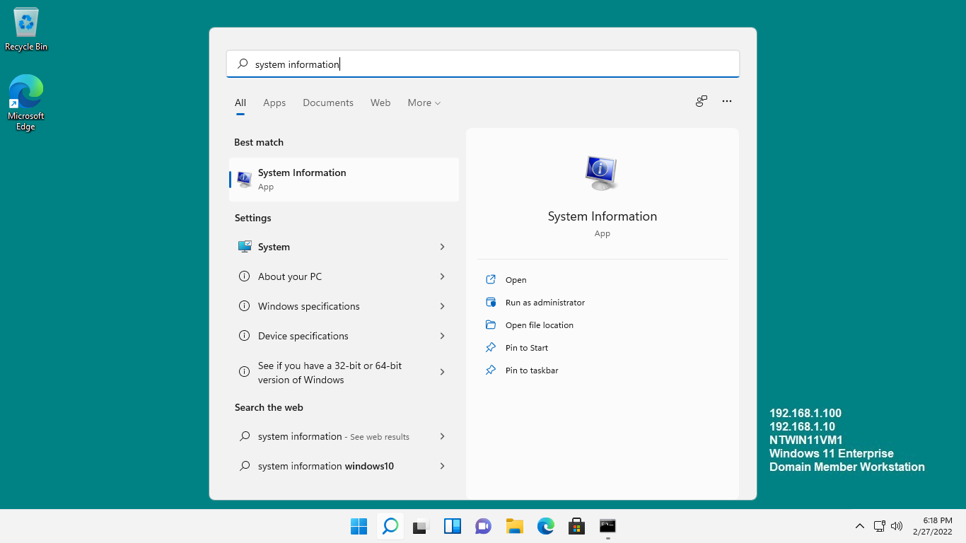

**Step 2:**

On the **System Information** window, access the menu bar at the top.

Click **File** and select **Print.**

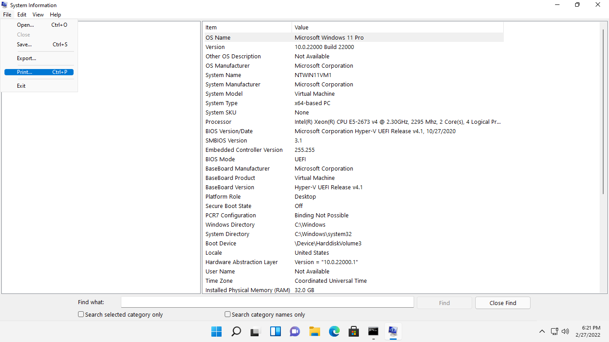

**Step 3:**

On the **Print** dialog box, ensure that the **Microsoft Print to PDF** option is selected.

Click **Print.**

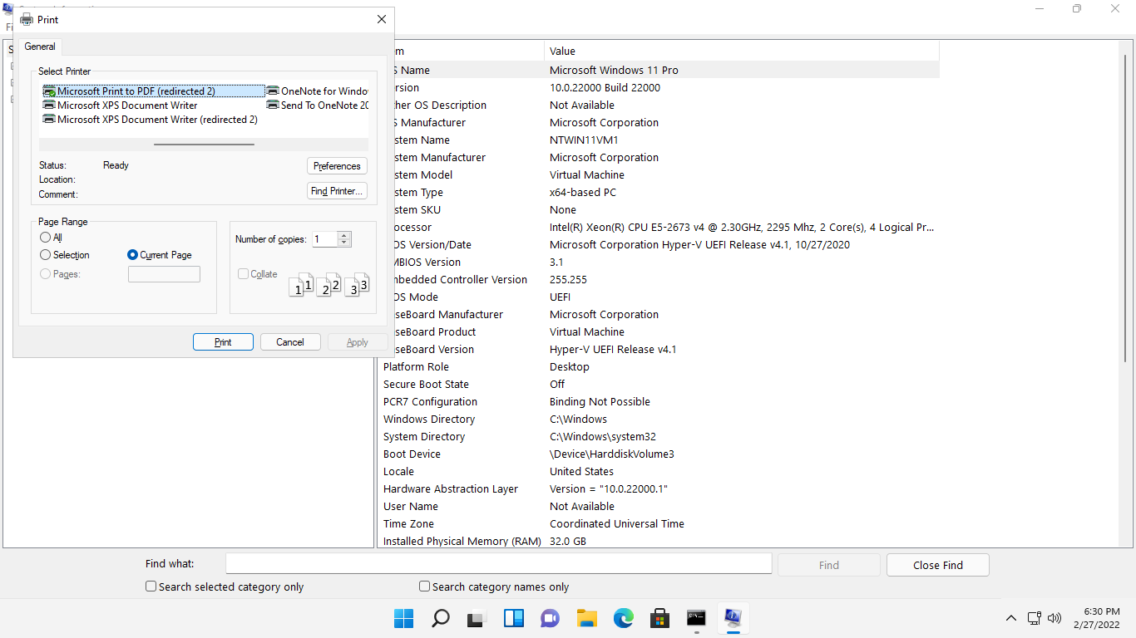

**Step 4:**

Please wait while **System Information** collects and refreshes data from various sources.

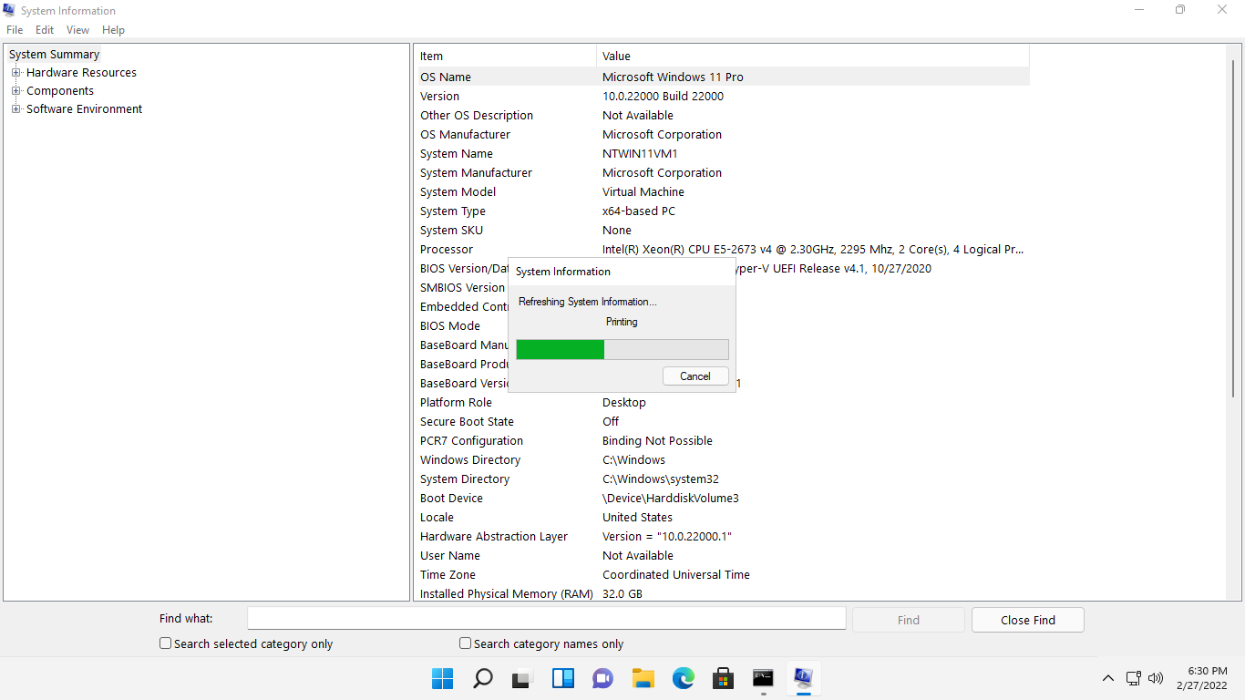

**Step 5:**

On the **Save Print Output As** dialog box, click in the **File** **name** textbox and type: ***ntwin11vm1***

Click **Save.**

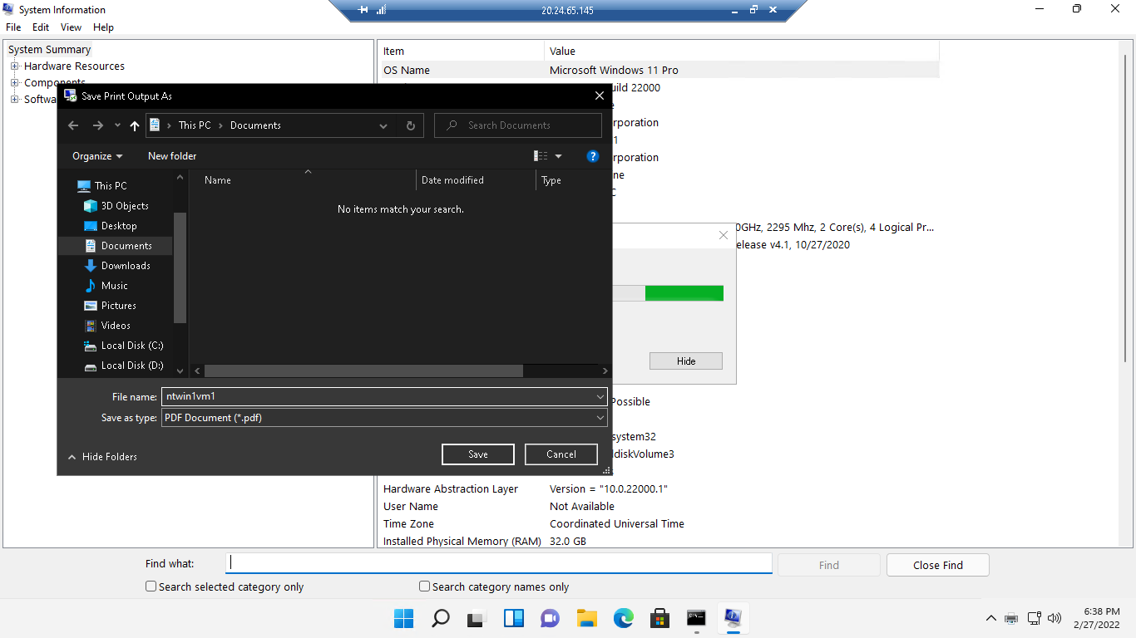

**Step 6:**

To access the printed report, click the **File** **Explorer** icon on the **Taskbar**.

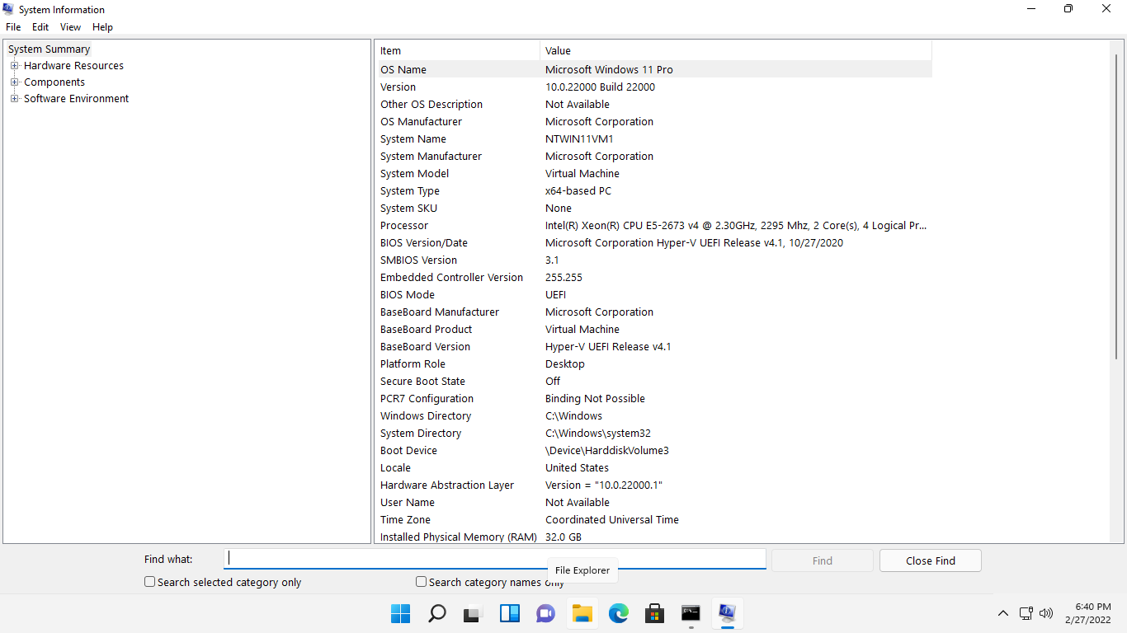

**Step 7:**

On the **File Explorer** window, go to the **Document** node then double-click **ntwin11vm1**.

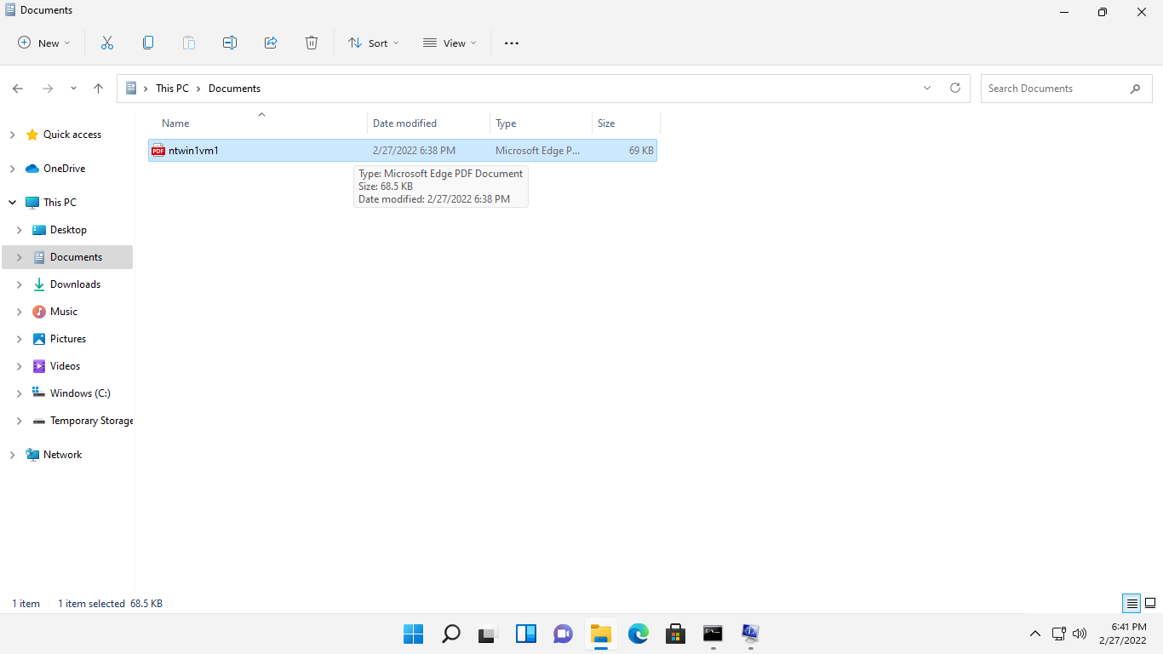

**Step 8:**

The **ntwin11vm1**.pdf displays the printed system report about the **ntwin11vm1** computer.

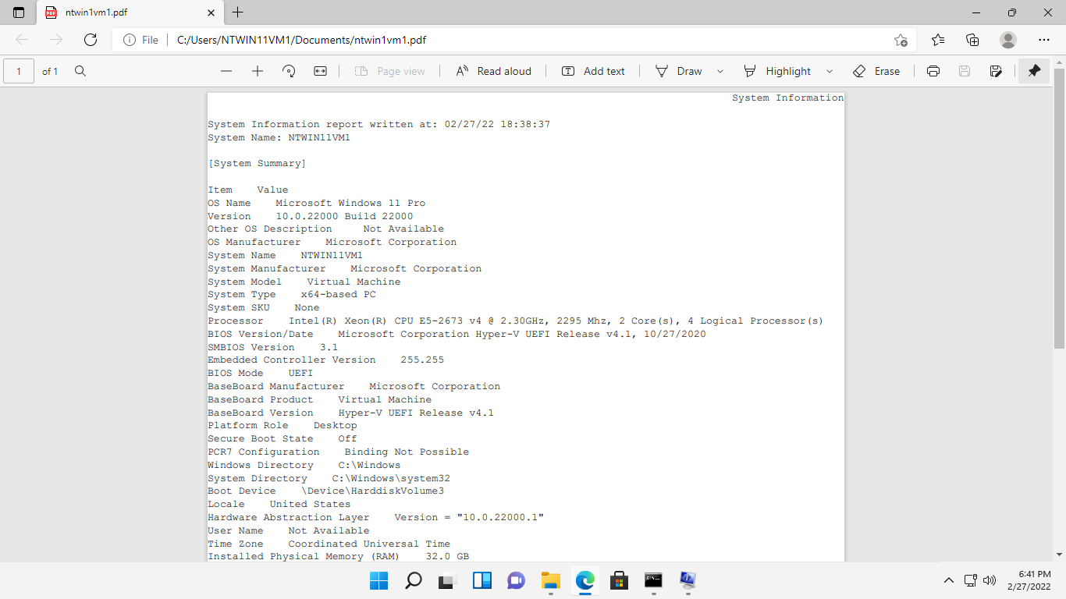

**Step 9:**

Close the **ntwin11vm1**.pdf and **File Explorer** windows.

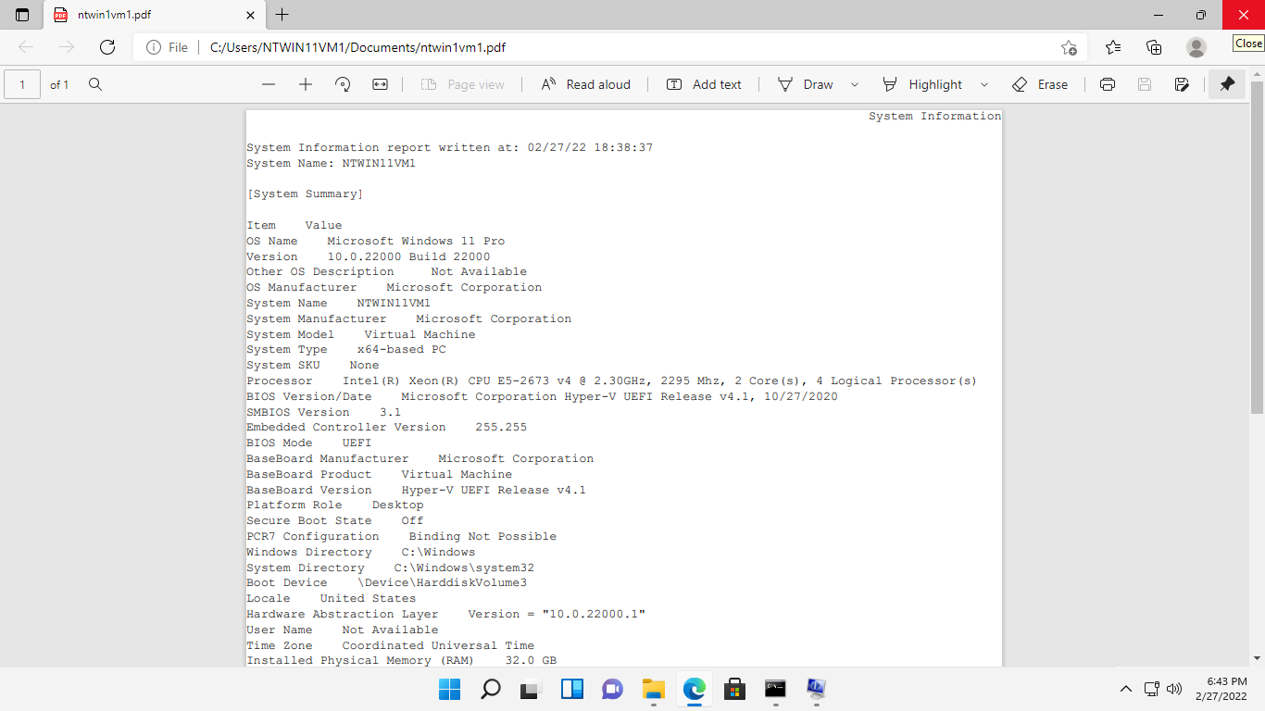

## **Task 2: Use System Information Tool to Collect Remote Information**

The System Information tool on one computer can be used to collect data on any other machine on the network remotely.

In this task, we will remotely collect system information on the **ntwin11vm1** computer, while you are logged into the **NTWIN11VM1** computer.

**Step 1:**

Make sure that you are connected to **NTWIN11VM1** and the **System Information** window is displayed

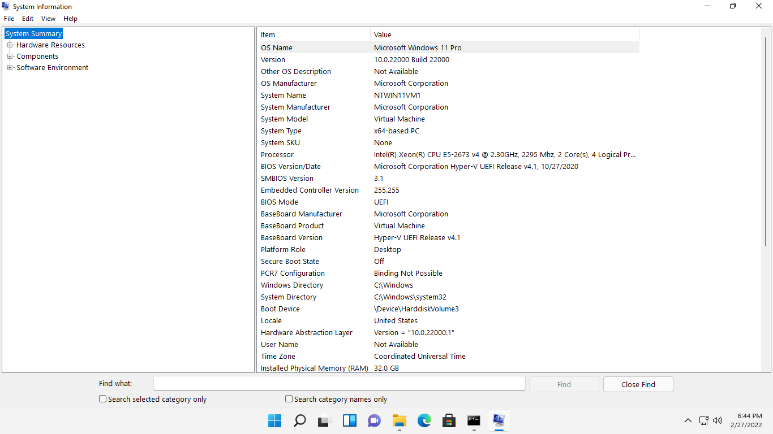

**Step 2:**

On the menu bar at the top, click **View** and select **Remote Computer**.

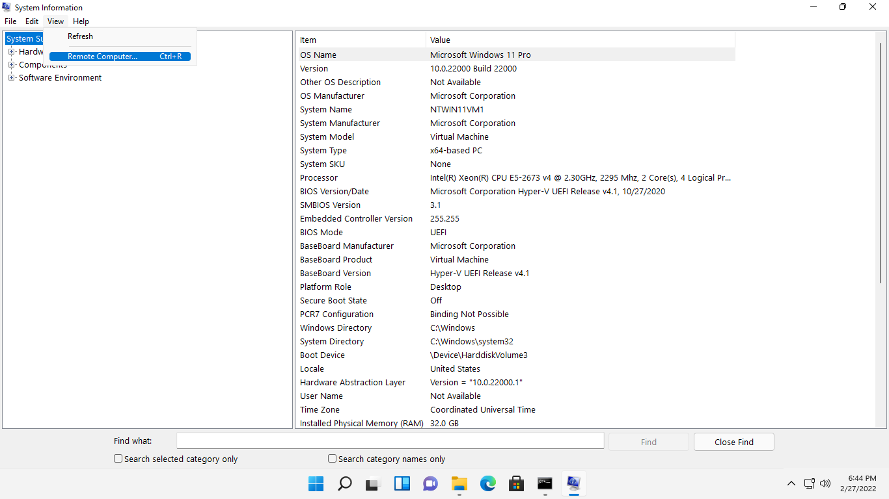

**Step 3:**

On the **Remote Computer** dialog box, notice that the **Local Computer** option is selected by default.

To access the information for a remote computer, select **Remote Computer on the Network** option.

In the provided textbox, type: ***ntwin11vm1***

Click **OK.**

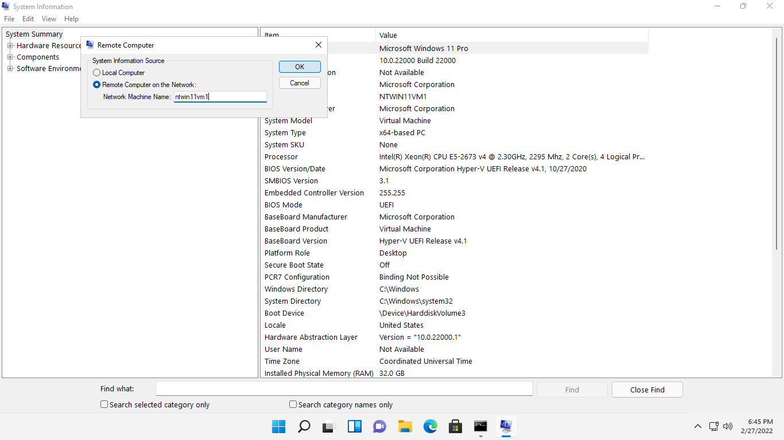

**Step 4:**

Notice the navigation pane on the left-hand side of the **System information** window now lists the \\**ntwin11vm1** computer name.

This verifies that the System Information window now displays system data about the \\ **ntwin11vm1** computer.

Examine the information displayed.

Close the **System Information** window when done.

